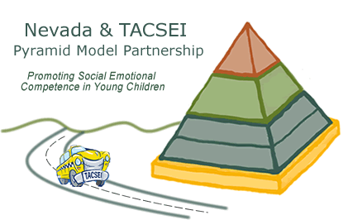**Nevada TACSEI Pyramid Model Partnership**

**Quarterly Update**

**July 2012 – September 2012**

**What our State Leadership Team has been doing:**

Our State Leadership Team continues to meet monthly and provides guidance for the Pyramid Model initiative throughout the state. We have been working on writing policies and procedures for all aspects of Nevada TACSEI’s work.

**What our Master Cadre Members have been doing:**

Master Cadre Members who are Internal or External Coaches continue to provide training and technical assistance to help classroom staff implement the Pyramid Model in classrooms and with families.

Master Cadre Members who provide training about the Pyramid Model have been busy teaching others about the Pyramid Model and its practices. We are in the process of hiring a consultant who will facilitate training in Southern Nevada. A regional training coordinator will also be hired in Elko as soon as someone qualified is identified.

Southern Nevada has added 4 Pyramid Model trainers/coaches to their team and Northern Nevada is in the process of completing Train-the-Trainers workshops and will add 6 additional Pyramid Model trainers/coaches at the end of November 2012.

**What our Demonstration Sites have been doing:**

Our Demonstration Sites continue to implement the Pyramid Model, meet monthly, collect data, and make decisions based on that data. We currently have 5 model demonstration sites. These sites will complete their fall data collection on October 26, 2012. The table below shows how many classrooms are currently implementing the Pyramid Model.

|  |  |
| --- | --- |
| Model Demonstration Site | Number of classrooms |
| College of Southern Nevada ECE Lab School | 4 classrooms |
| Washoe Tribe Head Start | 5 classrooms |
| UNR- CFRC/NEIS | 1 classroom |
| WCSD – Pre-K | 1 classroom |
| Head Start of Northeastern Nevada | 2 classrooms |

In addition to model demonstration sites, we are also working with new sites that have completed all modules in the Pyramid Model and are preparing to become *Implementation sites*. These sites are in the process of completing a readiness checklist, building a site leadership team, and creating a data collection plan; Reno Sparks Indian Colony in Reno, Little People’s Head Start in Ely, Nevada and 12 Clark County School District classrooms located throughout the school district, one in each zone.

**Family Coaching**

Pyramid Model education opportunities for parents are occurring throughout the state. NEIS-Reno has a cohort of 10 developmental specialists who are meeting monthly to share ideas for providing parents with support for preventing and addressing children’s challenging behaviors in the home. NEIS-Las Vegas has begun embedding the Positive Solutions for Families curriculum during their developmental playgroups.

**Trainings that have been conducted:**

We have conducted a total of 117 training events since our kick-off training in March of 2011. Since that first training, we have trained a total of 3, 898 participants across the state of Nevada.

**Upcoming training opportunities:**

Upcoming trainings will be listed on the Nevada TACSEI website: [www.nvtacsei.com](http://www.nvtacsei.com). The website is set to go live by the end of October 2012.

**Other:**

Training about the Pyramid Model is always available and can be tailored to meet a program’s needs